**Lab assignment 5.**

q-1) Create View Product Name And Create Table Salesmension column Sales ID,Product ID,Product Name,Price.

**Output:**

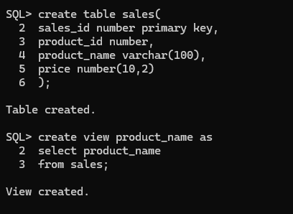

q-2) Create UNIQUE INDEX WITH Name of Index ISEmployee and Table Name Is EMP and mention columnEMP Name, Designation, Salary.

**Output:**

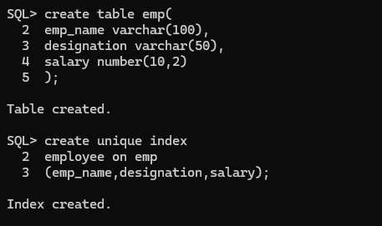

q-3) Create sequence inv_seq, which will generate thenumbers from 1 to 999 in ascending order.

**Output:**

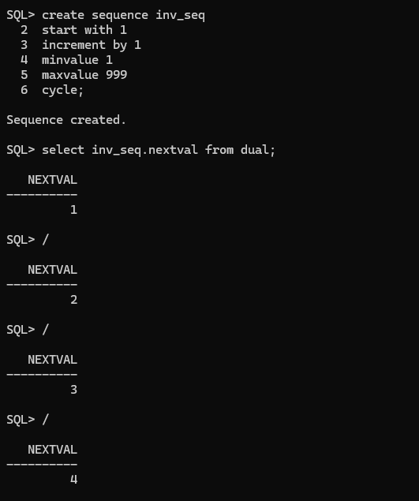

q-4) Use the sequence inv_seq to generate values for

inv_no column in the invoice_hdr table. Note that the

invoice number must start with ‘I’.

**Output:**

